**Semi-Conductor Diode**

**lab No#02**



**Spring 2021**

**CSE-206L Electronic Circuits Lab**

Submitted by: **Ashfaq Ahmad**

Registration No: **19PWCSE1795**

Class Section: **B**

“On my honor, as student of University of Engineering and Technology, I have neither given nor received unauthorized assistance on this academic work.”

Student Signature: ______________

Submitted to:

**Eng: Abdullah Hameed**

April 30, 2021

**Department of Computer Systems Engineering**

**University of Engineering and Technology, Peshawar**

**Objectives:**

* To study the characteristics of silicon and germanium diodes.

**Components:**

* Diodes: Silicon (D1N4002), Germanium (D1N4148) Resistors: 1kΩ,

**Semi-conductor Diode:**

Semiconductor diodes can be defined as diodes that are made up of semiconducting materials (typically, the metals silicon and germanium are used in them). In these diodes, the negatively charged cathode contains a large number of electrons, which is placed adjacent to the anode, which carries an excess of positively charged holes. Common examples of semiconductor diodes include the p-n junction diode and the Zener diode. The junction between the cathode and the anode in a semiconductor diode features the formation of a depletion region, which does not contain electrons or holes. When positive voltages exist at the anode, the depletion region becomes extremely small and the current begins flowing through the semiconductor diode.

**Internal structure of Diode:**

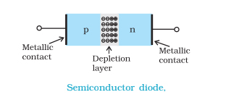

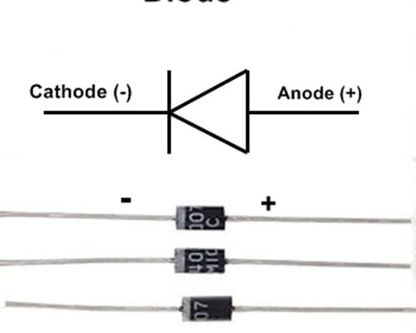

**Forward Bias:**

* Forward bias or biasing is where the external voltage is delivered across the P-N junction diode. In a forward bias setup, the P-side of the diode is attached to the positive terminal and N-side is fixed to the negative side of the battery.
* Here, the applied voltage is opposite to the junction barrier potential. Due to this, effective potential barrier and junction width decrease which further results in more majority of carriers flowing across the junction. Moreover, the amount of voltage required is also less for the complete elimination of the barrier. Forward biased PN junction forces the majority charge carriers to move across the junction. Due to this reason, there is a decrease in the width of the depletion layer.
* The number of holes and electrons are combined with each other once the junction is crossed.
* Each hole in P side combines with an electron that is from the N side. Due to this reason, a covalent bond will break and an electron generated from the covalent bond move towards the positive terminal.
* There is a formation of electron-hole pair.
* Holes carry current in the P region.
* Electrons carry current in the N region.

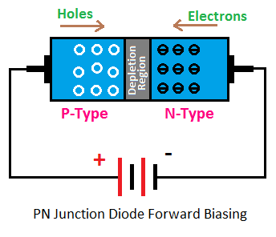

Porteus picture:

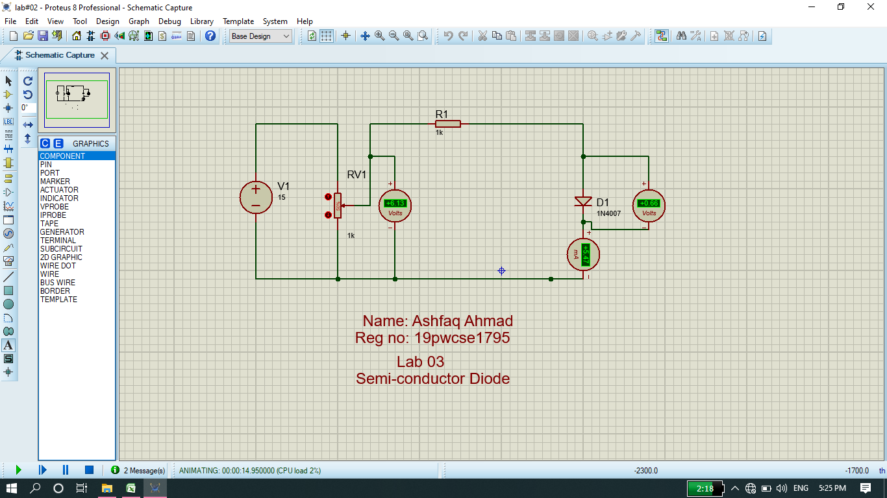

**Graph:**

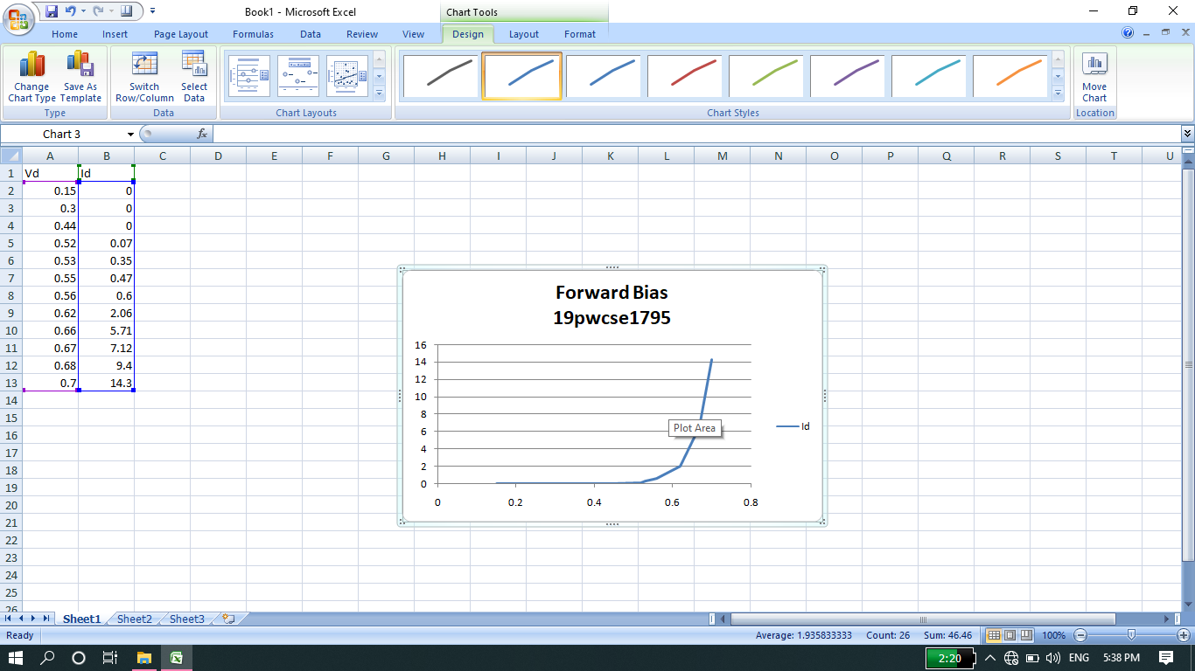

**Reverse Bias:**

If a voltage is applied across the diode in such a way that the n-type half of the diode was connected to the positive terminal of the voltage source and the p-type half was connected to the negative terminal, electrons from the external circuit would create more negative ions in the p-type region by "filling the holes" and more positive ions would be created in the n-type region as electrons are displaced toward the positive terminal of the voltage source. Hence, the depletion region would increase and the voltage between the p-type and n-type regions would also increase as the total charge on each side of the junction increases in magnitude until the voltage across the diode equals and opposes the applied voltage and cancels it out, ceasing the current through the circuit. This process happens nearly instantaneously and results in essentially no current flow through the circuit when voltage is applied in this direction across the diode. This is known as a reverse-biased p-n junction.

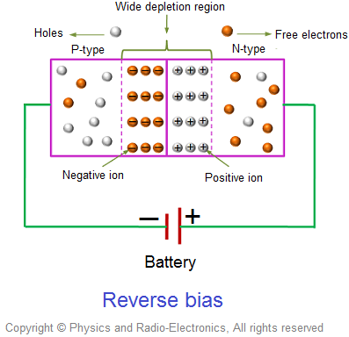

**Proteus picture:**

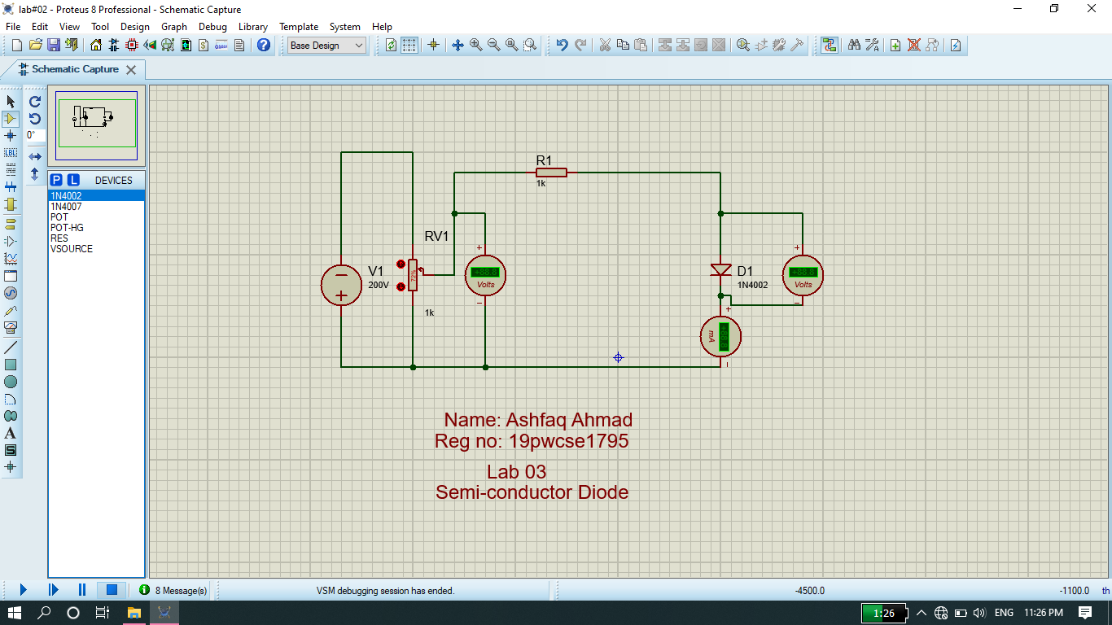

**Graph:**

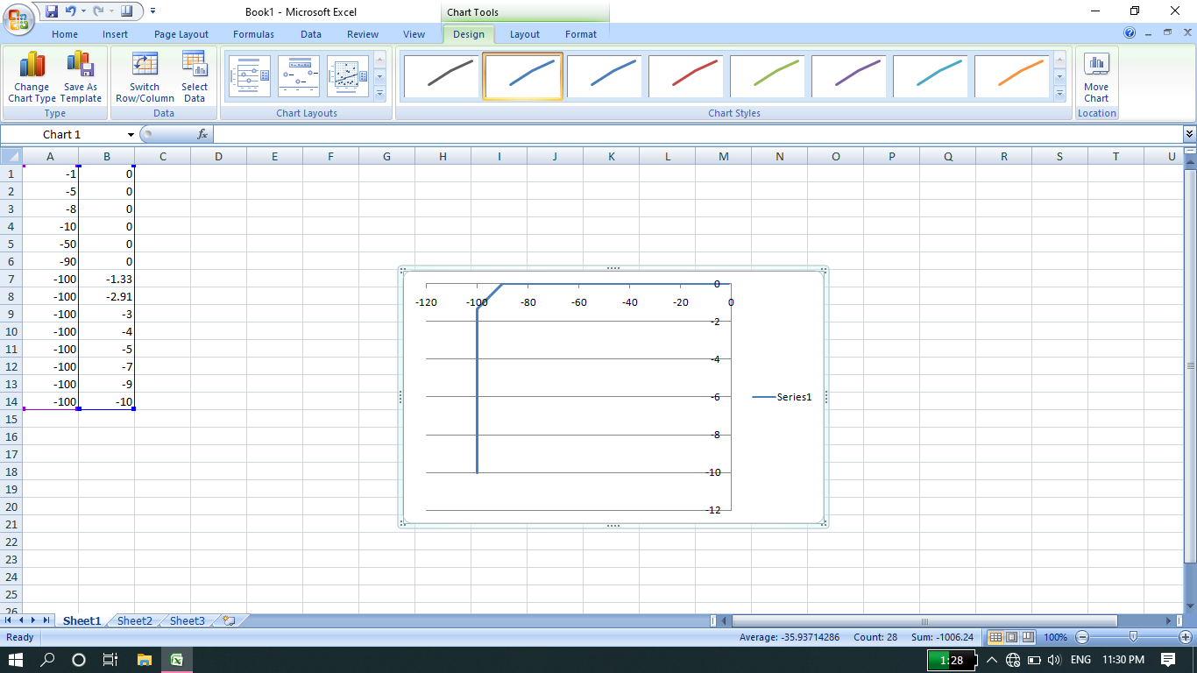

**THE END**